Brand Evolution Pre-Workshop Activity

Brands are all around us and seep into almost every aspect of our daily lives. Take a look around your home, or keep an eye out on the way to school. How many brands can you spot?

Can you name a brand example for the following types of products?
- Chocolate brand

- Clothing brand

- Car brand

- Digital/Electronic brand

- Drink brand

- Toiletry brand

Can you find an example of branded packaging for a product that you like?

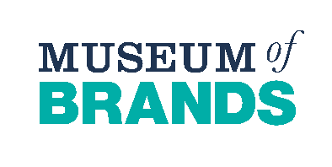
What do you like about the packaging? Why?

Brand Evolution Primary Pre-Workshop Activity
Brands are all around us and you probably see them everyday. We need brands to tell the difference between different products. For example, there are many different types of chocolate bar. What is your favourite? When you choose a chocolate bar you might get a Twix, a Dairy Milk, a Milky Way or a Mars Bar. These are all different brands of chocolate bar.

Take a look around your house. How many brands can you spot? You might need a parent help to you?

Can you write down an example of a brand you found in each of these places?

- Kitchen cupboard

- Fridge

- Bathroom

- Living Room

- Bedroom

Do you have a favourite brand? What do you like about it?

Brand Evolution Post Workshop Activity

Can you name the brand based on these images of historic packaging?

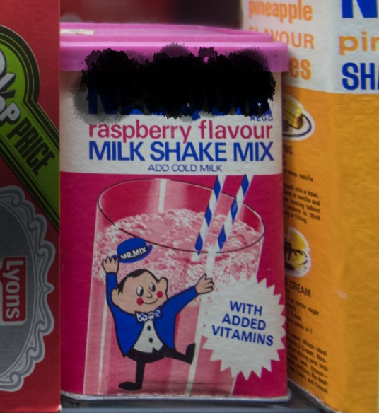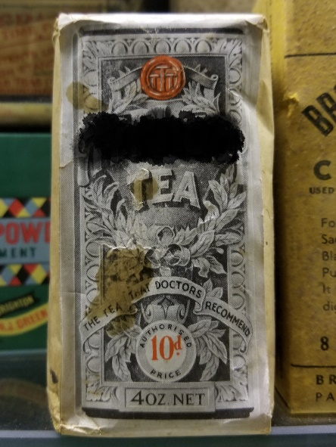

1._____________________________ 2. _________________________

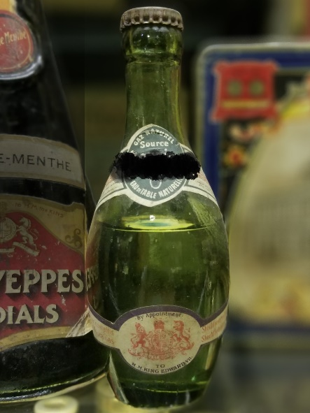

3._________________________

