Customer Profiling Pre-Workshop Activity

We interact with brands and products everyday as customers, from the things we eat, to what we wear and even just buy. Take a look at the packaging in your kitchen cupboard or around your home and pick a few examples to examine.

What kind of assumptions is the packaging making about its customers?

What sort of customers are excluded based on the packaging design?

How might this packaging be improved? Can it be more inclusive? Have a simpler design?

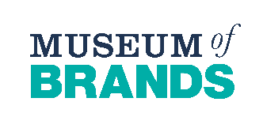
Customer Profiling Post Workshop Activity

Just as we have done recently in our workshop, companies imagine customers profiles when designing products and packaging so that they can better understand how to successfully bring in consumers. This means imagining age groups, careers, and more. Fill out the short questionnaire below and try to see how well the products you interact with might be aimed towards your customer profile!
- Your age?
- Your occupation?
- What is your status? Single/Couple/Family
- Do you love to buy? Luxury brands/Mid-range products/Budget friendly bargains
- What product/s do you buy?

What can you notice about the product design that is aimed towards a customer with a profile like yours?

What products might not “fit” your customer profile?

