Gender Stereotype Post Workshop Worksheet

Pick a product that you use in your daily life and think whether the product is specifically advertised to either male or female audiences.
Brand:……………………………………………………………………………………………..
Product:……………………………………………………………………………………..…..
Why do you think the product is targeting a specific gender?

How would the product be marketed differently if it was targeted to the opposite gender?

Do you think the products that are targeting a specific gender can be changed to be gender-neutral products? If so, how?

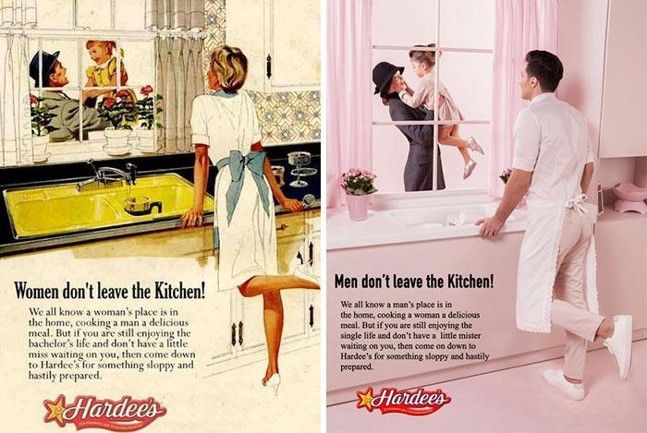

http://www.plastikstudios.com/inaparahlleluniverse
What does this company do to show gender equality through advertisements and sales of products?

What else could this company do to fight gender stereotypes?

What are some examples of gender-neutral advertisements and products today? How successful are they in the mainstream market?

