Graphic Design and Packaging Post-Workshop Activity

Logo design challenge:
Take a look at the table below;
Select an audience from column 1, a topic from column 2, and a product from column 3.
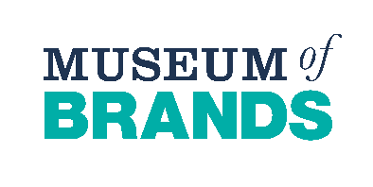
Invent a name for your product and design it’s logo below.

Audience | Topic | Product
Businesspeople | The Environment | Water Bottle
Teenagers | Art& Culture | Toy
Teachers | Sports | Backpack
Elderly | Technology | Chocolate Bar
Children | Vintage/Retro | Headphones

