Graphic Design and Packaging Pre-Workshop Activity

Packaging design is an essential part of the brands we love. Make a sketch of one of your favourite products’ packaging below.

Annotate your sketch to show what is effective about its design.

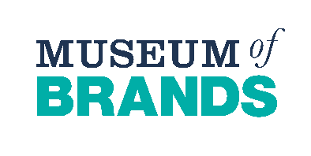
Does the packaging design appeal to a particular type of customer? How?

Graphic Design and Packaging Post-Workshop Activity

Logo design challenge:
Take a look at the table below;
Select an audience from column 1, a topic from column 2, and a product from column 3.
Invent a name for your product and design it’s logo below.

Audience | Topic | Product
Businesspeople | The Environment | Water Bottle
Teenagers | Art& Culture | Toy
Teachers | Sports | Backpack
Elderly | Technology | Chocolate Bar
Children | Vintage/Retro | Headphones

