Sustainability Worksheet

General Thinking Points/General Thoughts:
How do you envision sustainable packaging? Will you cut back drastically on packaging, use more environmentally friendly materials, promote and support a pro-environment cause? Complete at least 2 of the 4 tasks to bolster your presentation.

Let’s brainstorm! Come up with a couple of inspired ideas to make your product’s packaging more sustainable.
1ST Focus 2nd Focus

Evaluating your next steps!
Can your brand maintain (or even improve) their established levels of positive brand recognition and consumer satisfaction with drastically reduced packaging?
Packaging for thought? – If all UK packaging was limited by regulations aimed to cut down on waste, what effects could that have for brands?
Discuss and come up with suggestions of how you will convince consumers to accept a sustainable redesign of your product? E.g. It’s for the sake of saving the planet.
Now on a sheet of A4 paper redesign the product in front of you, bearing in mind your creative ideas!

Sustainability Rondo … think and act fast! (OPTIONAL)
Pick a question/scenario and come up with suitable responses.
1) Should we make all packaging simpler to make our consumption more sustainable?
2) Do brands have a responsibility to get consumers onside with sustainable packaging?
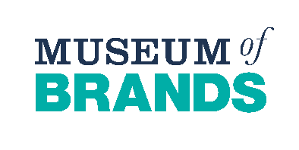
3) What would be the pros and cons of a supermarket standardising all its packaging, with the aim of building a more sustainable industry? For instance, how would you feel as a part of a popular brand, or, a longstanding consumer of certain brands
4) In terms of sustainability, what does our packaging tell us about our society today, e.g. public attitudes, our values?

C) Build-a-case study (OPTIONAL) Person A
Name/Occupation:
Age:
Social Demographic:

Opinion of your Brand:

Packaging related interests:

Challenge(s) for your Brand:

Task explained – Case study/Customer profile:
Person A is …
Firstly realistic! From a certain generation? Someone who thinks like many of your current or potential customers, you decide how someone of their age or social demographic relates with packaging on their household items.
So essentially create a case study profile of different demographics. We’ve given particular arrowheads but you can add different arrowheads explaining who they are and their interests. From your lived experiences you can tell us more than we can tell you, about people’s various perceptions of sustainability and packaging in their day-to-day lives.

D) Market research questions
1. How do you think this person (or your customers) will view the need/push for sustainable packaging?
2. How then would you sell this person (and people like them) on your sustainable packaging changes?

